Little SPARK: Simple Play Adaptations to Reference for Kids

Portable Communication Book
Description: | Image:
Wearable portable picture communication book with six clear 4” x 4” slip-in pages made of durable, washable, clear vinyl (plastic). | 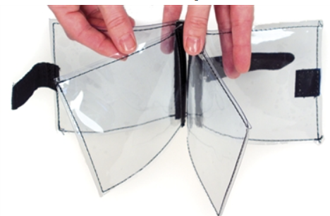

Who Might Benefit?
Those who need symbol support and a means of transporting their communication support to express and receive information at any given time.
Why Use?
Provides an opportunity to communicate on-the-go with a variety of communication symbols across 6 clear pages.
Instructions for Use: | Adaptation Ideas:
Environmental Considerations  - Use in any environment and on the go.  Positioning & Alternate Positioning  - Use in any position or attach to a slant board.  Basic Play/Use  - Place a picture symbol in the book, explain what it is and how it is used, and be consistent and make sure it is accessible.  Extended Play/Use  - Model use of the portable communication book. | Build It Up  - Edges could be built up or tabbed for easy gripping or high contrast.  Simplify It  - Introduce a few visuals at a time or organize by attribute.  Stabilize It  - Velcro to most surfaces.  Add Sensory Cues  - Add contrasting backgrounds or high contrast visuals.  Alternative Uses  - Use to display schedules, task sequences, etc.

